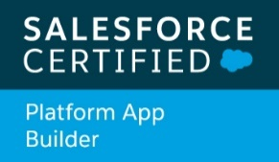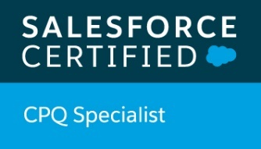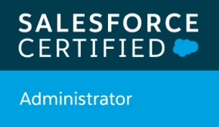

Sreenivasa Nagendra Kumar M
Email: kumar.sreenivasnagendra@gmail.com
Phone: +91 9493253163

CAREER OBJECTIVE

To work in a stimulating environment where I can apply and enhance my knowledge, skill to serve the organization to the best of my efforts and aim to provide my best efforts for management.
______________________________________________________________________________PROFESSIONAL SUMMARY

Modules – Sales Cloud, Salesforce1, Veeva CRM, Salesforce CPQ

Proficiency in SFDC tasks include
- Creating Profiles, Roles, Users, Page Layouts, Email Services, Approvals, Workflows, Reports, Dashboards, Actions, Tasks and Events
- Manage users, Public Groups, Profiles, and Roles within the Salesforce CRM; this involved designating access to the applicable user within the role hierarchy
- Skilled in customizing standard objects like Accounts, Contacts, Opportunities, Products, Price books, Cases, Leads, Campaigns and Custom objects as per client’s need
- Defined object and field level security
- Skilled in generating custom reports and dashboards
- Performed Validation Rules, work flows, e-mail services and approval processes
- Possess comprehensive understanding of CRM business processes like Campaign, Lead, Account and Sales Cloud flow.
- Skilled in Data Migration using Data Loader, Salesforce Import wizard, Workbench
- Experienced in implementation of Salesforce1 and Lightning features.

Extra Pro activeness
- Team player with good interpersonal skills, strong understanding of fundamental business processes, excellent Communication and Problem-solving skills
- Capable of rapidly learning new technologies and processes, and successfully applying them to projects and operations.
_____________________________________________________________________________WORK EXPERIENCE

3 years and 6 months of experience in Salesforce Application support
Duration: July 2015till date
Role: Application Development Analyst (Software Engineer) at Accenture working on Salesforce technology, Bangalore, India.

PROJECT DETAILS:
Project Name: Alcon (Envision CRM)
Duration: Aug 2015 till date
Technologies: Salesforce.com CRM, Force.com platform, SFDC Customization, Apex, Visualforce, Sales Cloud, Service Cloud, Salesforce CPQ

Description: Alcon is an American global Pharmaceutical medical company specializing in eye care products and surgical instruments. Project have different modules where Surgical users uses Sales cloud and Salesforce1 App, Pharma users use Irep app to market the pharmaceutical products manufactured by the client to the potential.

Responsibilities:
- Worked on Sales Cloud implementations
- Worked closely on Salesforce1, Salesforce CPQ.
- Analyzed requirements, Involved in the development of all modules
- Involved in understanding the requirement document and getting the clarification from design team.
- Implementing business process as per requirement in Salesforce.
- Developing and Testing in Sandbox then move in production.
- Daily support and resolving issues for all user of our organization
- Experience in handling 15+ Hyper Care supports for each go live.
- Creating TDD (Technical Design Document) for the change requests and CRQ’s for emergency changes.
- Provided Knowledge Transfer session to the users of the CRM application with respect to application, databases and change management.

- Administrative/Support tasks include- Create Reports and Dashboards,Scheduling reports,Create profiles, Roles, permissions, Organization wide defaults, sharing settings and sharing rules, Customizing compact and page layouts, working with security controls , access controls, user setups, monitoring workflows, validation rules, complex data uploads using Data loader, Import wizard or workbench.

- Development/Configurations/Customizations/Enhancement tasks include – Salesforce CRM, Formula fields, Validation rules, Custom Objects, Workflow & Approval processes, Reports, Dashboards, Profile, Role, Permission sets, Organization Wide Default Sharing, Sharing Rules, SOQL, SOSL.

TECHNICAL SKILLS

Technical | Salesforce and Force.com | Configuration: Salesforce CRM, Formula fields, Validation rules, Custom Objects, Workflow & Approvals, Reports, Dashboards, Profile, Role, Permission sets, Organization Wide Default Sharing, Sharing Rules
Technical | Tools | • Force.com IDE  • Data loader  • Salesforce workbench
Technical | Applications | Salesforce1  Veeva iRep  Salesforce CPQ
_____________________________________________________________________________________
EDUCATIONAL QUALIFICATION

COLLEGE / SCHOOL | UNIVERSITY/BOARD | EXAMINATION | CGPA/PERCENTAGE
Vellore Institute of Technology | VIT university | B.Tech(Mechanical Engineering) | 7.10 (CGPA)
Sri Chaithanya Jr.Kalasala | B.I.E | H.S.C | 95.1% aggregate
Keshava Reddy E.M High School | S.S.C | S.S.C | 91.08

PERSONAL INFORMATION

NAME: | Sreenivasa Nagendra Kumar Muchumalla
DATE OF BIRTH: | 03-04-1995
Father’s Name | Nagendra Kumar Muchumalla
Mother’s Name | Lakshmi Devi Muchumalla
Sex | Male
Marital Status | Single
Nationality | Indian
Permanent Address | Plot No. 203, Srinivasa Apartments,  Srinivasa Nagar, Nandyal, Kurnool (Dt.),  Andhra Pradesh.
Phone No | +91 9493253163

I hereby declare that the above written particulars are true and correct to the best of my knowledge and belief.

Yours sincerely,
Sreenivasa Nagendra Kumar M

